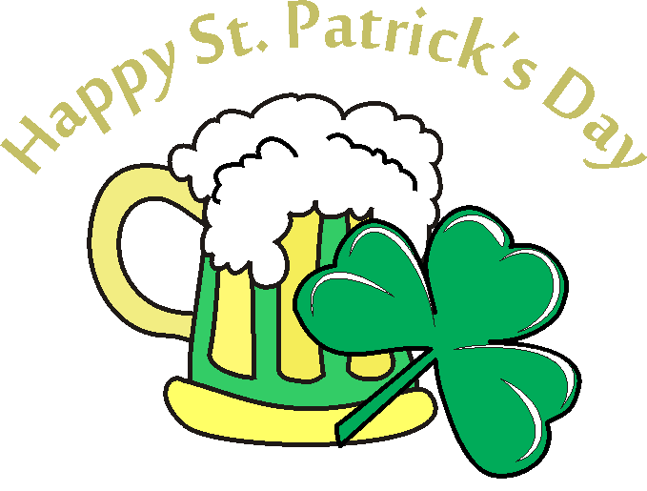

What: County Line Sno Busters St. Patrick’s Day Party
      - Corned beef and cabbage provided by Rookies
      - Club members are asked to bring either an appetizer or dessert for yourself and some to share with landowners
        - Landowners – you are our guest, please just bring yourself

When: Saturday, March 19th 2022

Where: Rookies Food and Spirits, lower level clubhouse
10267 US-14, Mazomanie, WI 53560

Time: 3-7pm

Questions: Contact Ron Haugen, email: CountyLineSnoBusters@charter.net

Phone: 608-516-4495

Hope to see you there!



